Creating custom images for VMs:

1. Create from a Marketplace Image
2. Upload a VHD from a local VM

Start with a base VM 🡪 make modifications to VM 🡪 generalize (Windows VMs)/deprovision (Linux VMs) the image 🡪 stop and deallocate VM 🡪 mark image as generalized 🡪 create custom image 🡪 create VMs from custom image

Note: Custom images consume space, so meh

If VMs are using managed disks -> custom images are stored as Managed Disks in resource group  
If VMs are using unamanged disks -> custom images are stored in Storage account

If a custom image is located in another region, we have to manually copy it to another (where we want to initiate a VM)  
-> Azure CLI has an Image Copy Extension  
-> PowerShell: manual process

**Generalized VMs themselves cannot be started anymore.**It lives on as an image, the VM can be even deleted (image is kept):

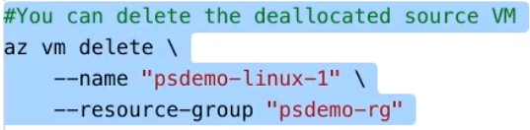

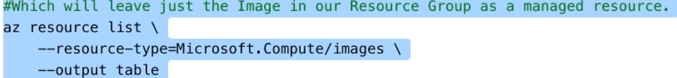

# Generalize Windows VM

**sysprep**: With Windows VMs, this is used to generalize the VM

* Resets security ID and other computer specific info
* sysprep.exe /generalize /shutdown /oobe
* (out of box experience)
* ...then shutdown and deallocate VM

# Deprovisioning Linux VM

**waagent** (from Azure VM agent)

* Included in Azure VM images coming from Marketplace (or can install it on my own distro’s package repo [Extra’s repo usually])

sudo waagent –deprovision+user –force

...then shutdown and deallocate VM

# Step by step: Linux w/ Azure CLI





(use IP from here..)

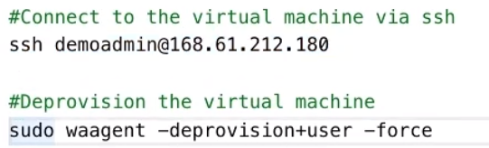

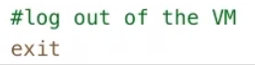

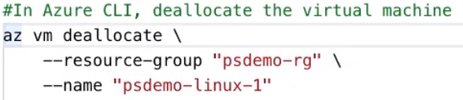

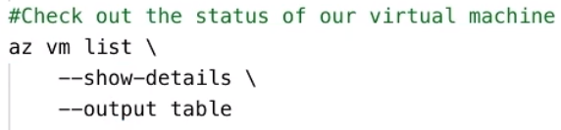

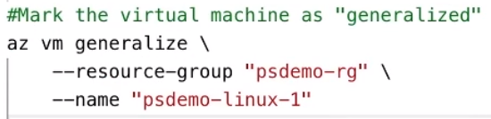

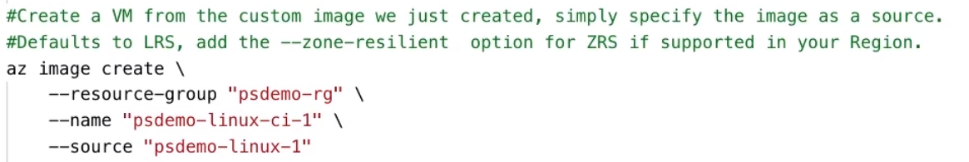

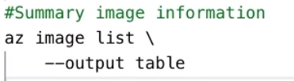

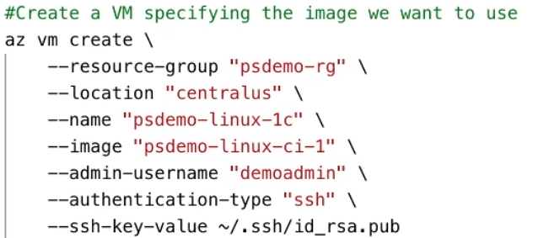

# Step by step: Windows w/ PowerShell



  
(this is to be pasted in the command line on the R DP’d VM)  
(required admin permissions, obviously)  
(automatically shuts down VM)

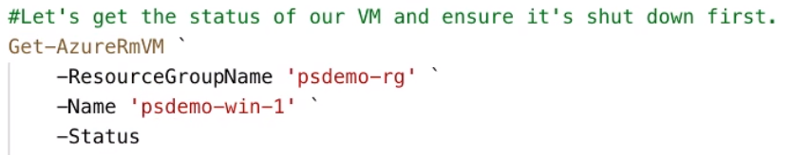

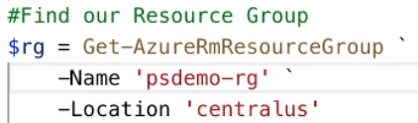

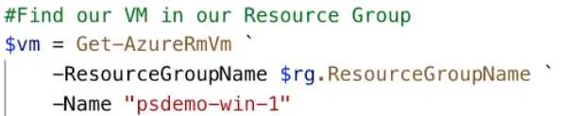  
(has additional parameter of –Status)

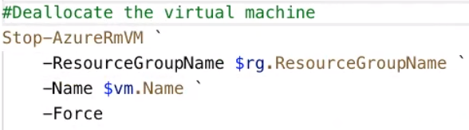

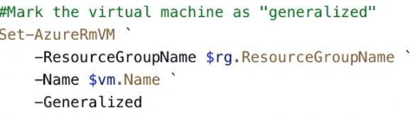

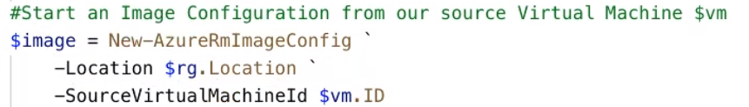

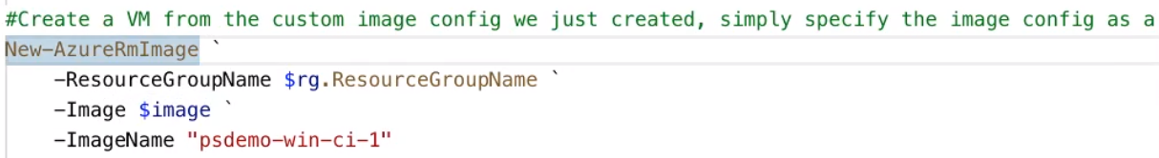



(has a property of –ImageName ’psdemo-win-ci-1’)



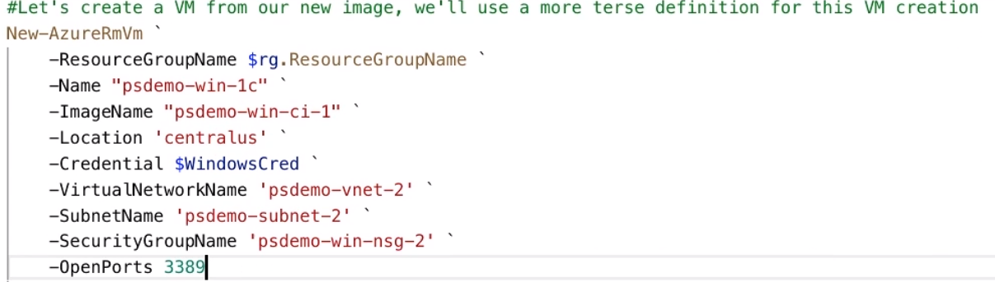

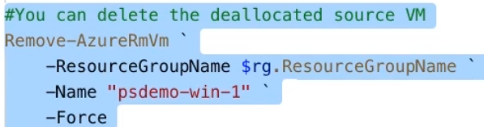

(this leaves the image)

Moving images between regions

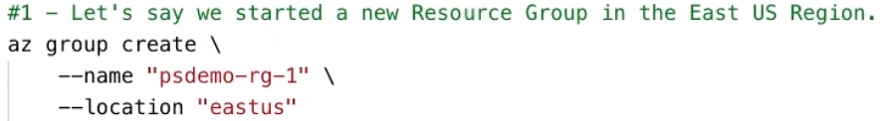

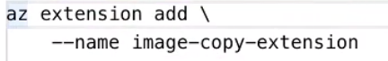

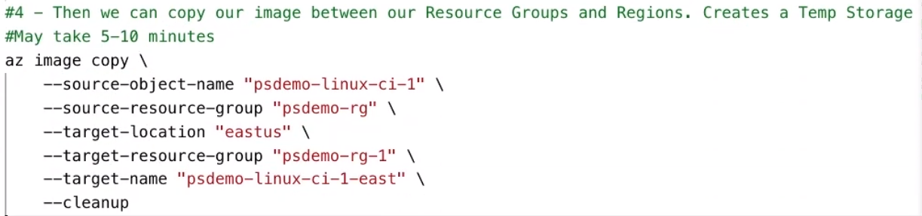

Source object name: source image’s name